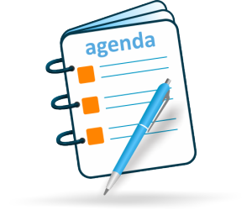

Rev. 5/2019

Thank you for your cooperation!

IN ORDER TO MAINTAIN YOUR MEDIA CENTER/MAKERSPACE PRIVILEGES, PLEASE FOLLOW THESE GUIDELINES…

1. Visit the MC/MS for a signed pass in your AGENDA at the start of the school day.
2. You MUST remain in your Study Lab for the first 15 minutes of the Block. Proceed to the MC/MS with a signed and time stamped pass in your AGENDA from your Study Lab teacher.
3. You MUST remain in the MC/MS the entire Block unless prior arrangements have been made; otherwise, you will NOT be given a pass to return to your Study Lab.
4. LIMITED passes will be given to visit lockers. Students must come prepared to work.
5. NO passes will be given to visit teachers.
6. Restroom passes will be monitored.
7. Electronic devices are permissible for school related work ONLY.
8. NO food may be consumed. Capped water bottles are permissible. NO canned beverages.
9. NO game playing unless you have made the game in the THS Makerspace!
10. The Media Center/Makerspace is a place for both quiet and collaborative work. Let the staff know you needs in advance!
11. There are limited passes ~ plan ahead!
12. All other rules outlined in the Student Handbook will be applied and enforced if necessary!

**STUDY LAB EXPECTATIONS IN THE**

**THS MEDIA CENTER/MAKERSPACE**